Chapter 19, Problem 81.

Repeat Prob. 19.26 using PSpice.

Chapter 19, Problem 26

Calculate [y] for the two-port in Fig.19.84.

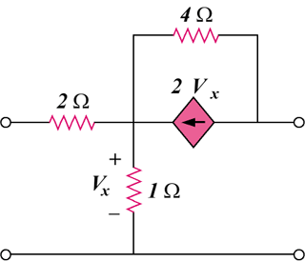

Figure 19.84
For Probs. 19.26 and 19.81.

